Improvement Plan of the Credit Application in Esenttia S.A.

KAREN DAYANA ALBA MALAGÓN
1710010081

University Internships
International Business
Eighth Semester
2020

Sandra Milena Chicas Sierra

BOGOTÁ D.C.
CONTENT TABLE
LISTS 3
LIST OF FIGURES 3
LIST OF TABLES 3
LIST OF ANNEXES 3
OBJECTIVES 4
Overall objective 4
Specific objectives 4
JUSTIFICATION 5
IDENTIFICATION OF THE COMPANY 6
Functions description: 6
Company activities: 7
Mission 7
View 7
PROBLEM TO SOLVE 9
Problem formulation 9
Functions for improvement 9
METHODOLOGY 11
Focus 11
Information sources 11
Research method 11
Techniques and instruments 12
Techniques 12
Instruments 12
Application 13
Improvement plan 15
Details of the current situation 15
Proposal 16
Actors involved in the process of improvement 19
RESULTS 21
CONCLUSIONS 22
RECOMMENDATIONS 22
REFERENCES 23
ANNEXES 24

LISTS

LIST OF FIGURES
Figure 1. Esenttia's Organization Chart. Source: Own elaboration. 8
Figure 2. Impressions - Head of credit and portfolio area. 21
Figure 3. Impressions - National clients analyst 21

LIST OF TABLES
Table 1. Record of requests in August. Source: own elaboration. 13
Table 2. Record of requests in September. Source: own elaboration 14
Table 3. Record of requests in October. Source: own elaboration 14
Table 4. Application of the form. Source: automatically generated from Office Forms. 15

LIST OF ANNEXES
Annex 1. Register of received requests. Source: own elaboration 23
Annex 2. Online form. 27
Annex 3. Current credit line request flowchart. Source: own elaboration. 29
Annex 4. Credit line request flowchart proposal. Source: own elaboration. 30

OBJECTIVES

Overall objective
Design an optimization proposal for the national and foreign clients’ credit application procedure in the credit and portfolio area of Esenttia S.A.

Specific objectives
- Describe the national and foreign analysis software that is being used to develop the analysis of credit applications.
- Identify the critical points of the credit procedure that cause delays in the execution of credit analysis and response times to both national and foreign clients.
- Design the flowchart of the credit management process to serve as a guide for the correct and timely filing of credits in which interns have more participation.

JUSTIFICATION
One of the objectives of hiring interns, besides from helping them to develop their skills and be their entry to the work world, is to have support staff in areas that require it, in fact, according to Chegg, Inc (2019) “An intern can make real contributions to productivity now, helping your full-time staff avoid becoming overburdened by side projects, and freeing them up to accomplish more creative tasks or tasks that require high-level expertise” (p. 1).
Therefore, in the credit and portfolio area of Esenttia, interns facilitate mainly the preparation of studies, however, they can contribute more to productivity if unnecessary processes are removed. This comes along with organization because there must be an appropriate level to avoid delays in procedures and client response times, this includes the delegation of specific functions to the members of each team, otherwise, tasks can be behind schedule. As every procedure has its own flowchart, it is important to review which steps of it are being significative to the final result and the process itself, in consequence, if the flowchart is optimized the conduct of both national and international business will benefit, along with the reputation of the company as it is going to be more efficient giving response to its clients.
Keeping in mind the mentioned aspects, it is understood that this paperwork is of utmost importance for the credit request process as it identifies and details the crashes that it has and suggests an optimal solution through organization and standardization of functions.

IDENTIFICATION OF THE COMPANY
Company name: ESENTTIA S.A.
NIT. 8000594705
Addresses: - Plant in Cartagena: Marmonal Industrial Zone, Kilometre 8, Cartagena.
- Bogotá Office: Carrera 10 N. 22 – 49, Tower A, Floor 27, Bavaria Building-Davivienda, Bogotá.
National phone number: 234 39 00
International phone number: 01 800 912 1013
Webpage: esenttia.co

Functions description:
- Support in the analysis of credit applications for national and foreign clients: classification of financial statements, search for information in sources controlled by the company, preparation of financial reports, analysis, and recommendation.
- Support in client profitability studies or special reports that are developed in the area, with management coordinated with the Analysts.
- Support in collection management of national clients.

Company activities:
Esenttia S.A. is a company that is part of the industrial sector, it is dedicated to the production and distribution of plastic that is used as raw material, it has three categories of products: polypropylene, polyethylene and masterbatch. It markets its products nationally and internationally, mostly in Central and South America.
Esenttia was born in 1989 initially with the name of Polipropileno del Caribe S.A., (Propilco) specializing only in polypropylene. Comai Ltda. arises in 1991, which complements the product catalogue with different polypropylene compounds, colour masterbatches and additives. Years later, in 2008, by increasing its production capacity and adding polyethylene to its catalogue, Propilco (conformed by Propilco and Comai) joins the Ecopetrol Group. In 2014, upon consolidating itself as a key ally in Colombia, Esenttia S.A. was established and in 2016 Esenttia Resinas del Perú was created (Esenttia S.A., 2020).
The organizational culture and the organization chart of the company are presented according to Esenttia (2020, p. 1).

Mission
“Provide innovative solutions to the world of plastics, contributing to the sustainable transformation of society”.

View
“To be a vital ally of the plastic consumer industry in Latin America, through differentiated service models and innovative human talent.”
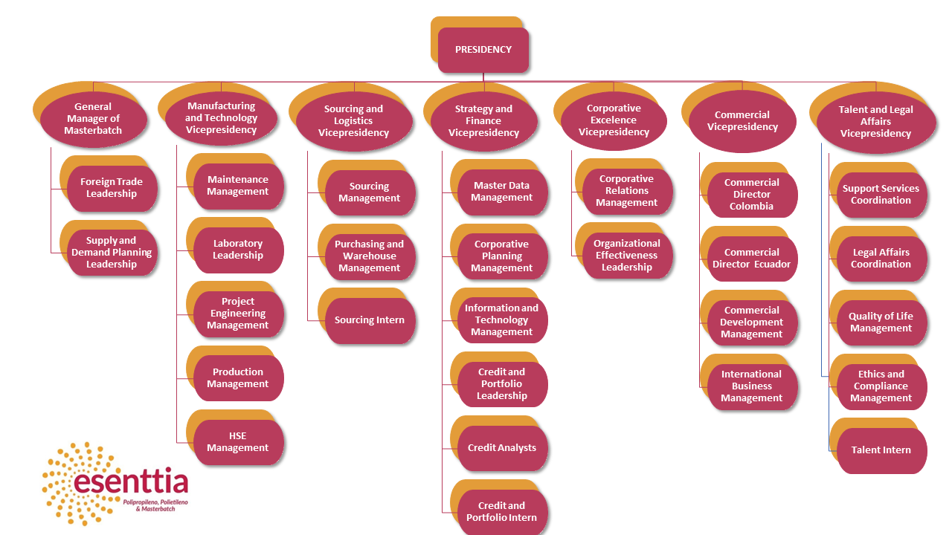
Figure 1. Esenttia's Organization Chart. Source: Own elaboration.

PROBLEM TO SOLVE

Problem formulation
Esenttia's credit and portfolio area uses a software for credit studies of national clients and an Excel format for studies of foreign clients. In order to manage these studies, it is necessary for clients, through the commercial area, to send a series of documents such as partial financial statements and for the previous two years, in the case of new clients, additional to those already mentioned it is requested another series of documents such as commercial references (which need to be confirmed by calling/contacting them), the verification in the restrictive security lists, the deep and detailed analysis of the chamber of commerce or document that establishes the constitution and legality of the company;
On the other hand, the current process for assigning credit studies to interns is that the analysts first receive the email from the commercial area and then it is forwarded to the interns. When there are missing documents, which happens on average 25% in a month, for example financial statements of the current year (as of March, May, June or July depending on the country) which are very important to analyse the current performance of the clients, the intern notifies the analyst and the analyst to the commercial area, generating double effort and time invested in a single study, which delays the response time up to 5 more days, especially when it comes to new clients, since as already mentioned above, require a more extensive document verification.

Functions for improvement
Initially, it is pertinent to use the current template, along with the test of the software that will be implemented, this will be done by entering data of different studies. Once done this phase, it is essential to migrate the digitalization of documents for foreign studies to the software used in national studies, the intern will work along with the IT department to test the software.
Secondly, it is pertinent to make a record of the studies and the periods of time that each case lasts to identify the weak points of the process.
It is necessary to have an organized and logic credit application procedure in order to be more efficient, for this reason, the functions of the interns and their role in supporting credit analysis, specific cases -such as new credit requests- should be assigned directly to them and thus reduce time throughout the process. By restructuring the current flowchart of the procedure, the intern will start playing a crucial role in the process since she/he will start having more contact with the commercial area and update in real time the credit analyst about the status of the requests.

METHODOLOGY

Focus
The present improvement proposal will follow both the quantitative and qualitative approaches, it is, a mixed approach, which according to Dr. Hernandez (2014) is characterized for “reflecting the need of measure and estimate magnitude of investigation problems: how often do they happen?” (p. 38), thus, the data collection is based on the measurement. Therefore, the measurement of the current credit credit application flowchart leads to the identification of the flaws in the process that need to be improved and the qualitative approach will be evidenced in the used technique.

Information sources
The main information source was the data base of Esenttia S.A. -within the limits of the functions and accesses of the credit and portfolio intern role- along with the technique and instrument which were used to register the received credit application studies and the main characteristics of each case to meet the objectives set. Additionally, to support the proposal articles from various internet magazines and case studies were consulted.

Research method
The improvement plan proposal sticked to the descriptive method as it “describes phenomena, situations, contexts and facts; this is, detail how they are and how they show” (Sampieri, 2020, p. 1), as mentioned above, both the data entry of foreign clients financial information and the flowchart of the credit application will be detailed to show the frequency of inconsistences and the impact on the bottom line.

Techniques and instruments
To collect the information needed to develop the proposal, there are techniques and instruments that allow obtaining organized and correct material, these are strategies that were implemented to enrich knowledge and the details of the current situation.

Techniques
The technique used to collect data was direct observation, having the intern as a full participant, in this category, “the researcher is one more member of the group studied, but hides her role as an observer to avoid interruptions” (Nuñez, 2020, p. 1), being so, once the intern started her functions in the area and observed the weak point of the process, a record of each credit application started being structured to identify in how many cases the role of the intern can contribute more to be more efficient, reduce response times and be more helpful to the analysts. The data was collected daily and/or each time there was a notification about each request and presented monthly.

Instruments
Keeping in mind that the technique used was observation, the intern created a record of each credit application, there are three tables in total in which it can be evidenced the type of request, the lapse of time between the commercial area and the analyst and the date in which the intern received the notification about it to have punctual and in-real-time-recorded information, this information can be corroborated in the filer of the area. In the Annex 1. Register of received requests, it is shown some of the main cases that had more impact in the present project, however, it is proper to mention that each case was recorded in the same formats and the consolidation of them is exposed in the next section.
For the results section, an online form was designed and sent to the analysts which will be part of the improvement plan, in it, both the current flowchart and the proposal were presented and after asking for basic data (name and position in the area), an space was opened for them to give their impressions of the proposal, as shown in Annex 2. Online form.

Application
The data collection process started since August 3rd of 2020, the date the intern started developing her functions in the area. A record of each credit application request was made as soon as it was received, that could be daily or weekly, however, the present improvement plan is based on monthly metrics about these studies, classifying them by the type of study requested and also detailing if there were inconsistences in the process -such as missing or wrong documents- and how long it took to finish the study to be sent to the head of the area, additionally, it is evidenced how long each study took to be sent to the intern. The following tables show the record done.
Table 1. Record of requests in August. Source: own elaboration.
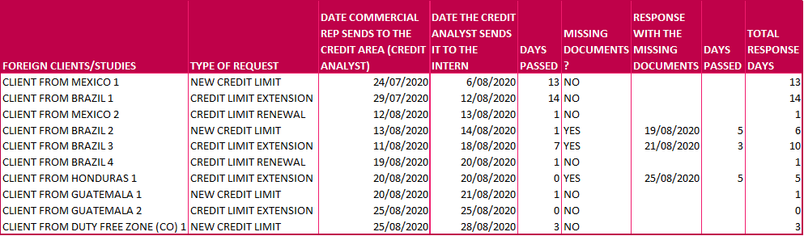
Table 2. Record of requests in September. Source: own elaboration
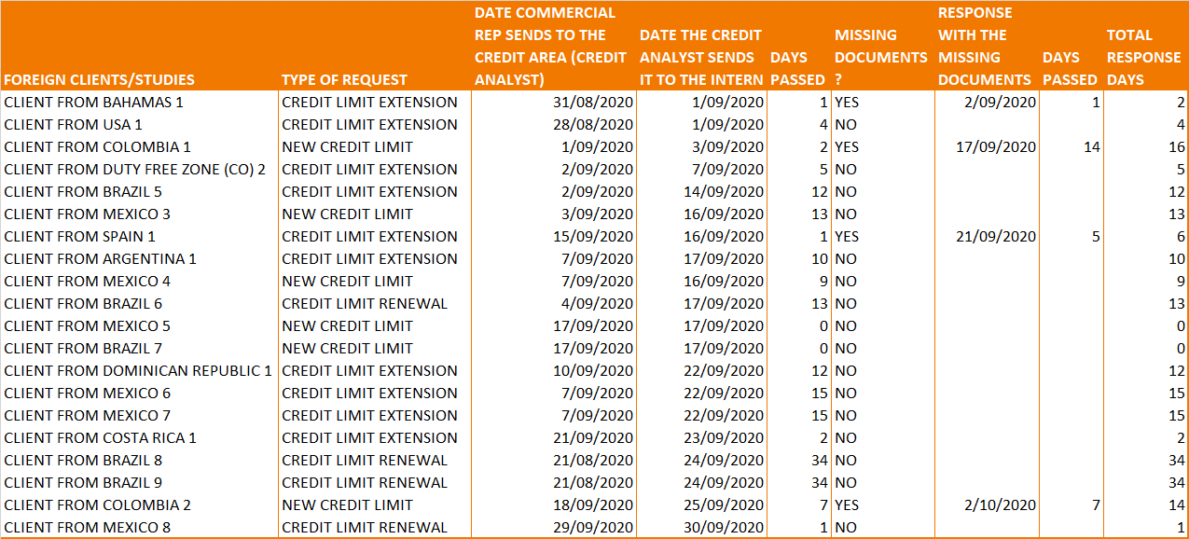
Table 3. Record of requests in October. Source: own elaboration
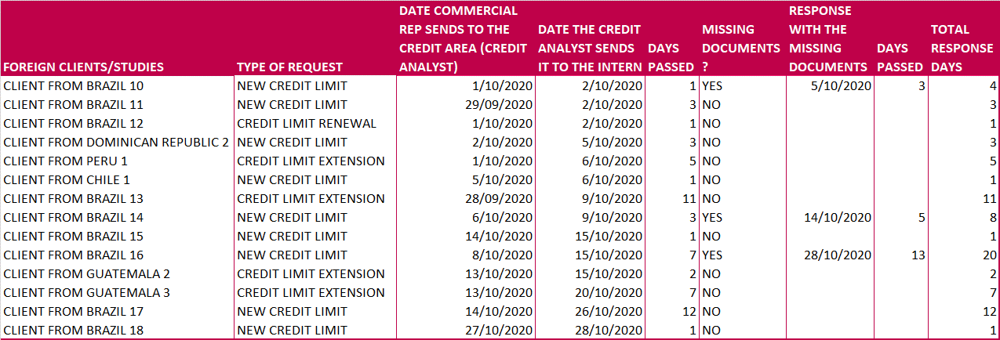

The results of the survey are revealed below
Table 4. Application of the form. Source: automatically generated from Office Forms.

Improvement plan

Details of the current situation
The credit and portfolio area is divided in national clients and foreign clients. When receiving a credit line request from the commercial department, the credit studies of national clients are made in a software called SAP, that stands for “Systems, Applications and Products in Data Processing” (SAP SE, 2020), which also stores the essential data of the clients, their history in the company – such as since when they joined the company and their official phone number, including brief notes about previous requests or incidents-, their payment history, the current balance of the portfolio, and the history of all the orders they have placed. Therefore, once the analysts have received the client’s financial information, they type in SAP the specific data needed for the study and the final step, after uploading the analysis, is saving the file in PDF format to be presented to the head of the area so she approves or deny the recommendation of each analyst.
In addition to that, when doing a foreign credit study, a Microsoft Excel format is being used. In there, the first sheet is designed to write the data, which are the same accounting accounts as in national studies, the difference is that the data is typed in the currency of the given financial information, e.g. usually, when the client is from Brazil, its financial statements are in BRL (Brazilian Real) or when the client is from Mexico, the currency is MXN (Mexican Peso), and also it is needed to search online the currency conversion according to the date of the financial statements. Additionally, as the format is used to be in blank, it is necessary to type all the information of the client in it, including their tax identification number in their respective country, and also the information that is already in SAP, and the formulas convert each cell to USD (United States Dollar).

Proposal
As it can be inferred, foreign studies take more time to be finished and as they are in an Excel format, mistakes can be done such as changing accidentally a formula affecting the analysis or, for example, when the study is made one week before presenting it to the head of the area, there can be some data about the portfolio that may have changed in that period. For this reason, it would be pertinent to migrate the Excel format to SAP. For this, the algorithm in SAP can be the same as in the national studies, with the difference that it is going to be needed an additional step that is the conversion to USD. Considering that the main idea is to reduce time in the process, this is the proposal: the Information Technology Department can migrate Excel to SAP and adjust the algorithm so every time it is entered a currency the software saves that information and in the next client from the same country, the software will automatically show the conversion of the currency.
To illustrate, the client XYZ from Brazil requests a credit line study in September and sends financial information from December 31st of 2018 and 2019, and to the August 31st of 2020 cut. The conversion at the cut of each date is BRL 3.87, BRL 4.02, BRL 5.38. Therefore, when another client that has its financial statements in BRL requests a credit study and provides information with the same dates, it is not going to be required to search for the conversion again but only start typing the financial data. When creating or modifying a transaction in SAP, the IT Department has a preliminary phase which is called “Tests” in which the transaction is rehearsed before being released for use. The intern will be the one who will work along with the IT Department in this phase by doing simulations and communicating which are the mistakes that the software has and he/she can even propose improvements, as in this case it is to save the currencies to optimize the process. Case studies, like credit studies that are already done, will be used to identify the bugs and then a report will be sent to the IT Department to request their help fixing it. It is pertinent to mention that once the intern gives the final feedback to the IT Department, the analysts who use the transaction, in this circumstance is the analyst to whom the foreign clients correspond, will test the transaction with the corrections that the intern suggested.
The current flowchart of a credit line request (for a new client or a new credit limit) is the presented in the Annex N.1.
When the commercial representative sends the filling of the request, the credit analyst sees it between one and seven days after, as shown in Table 1. Record of requests in October (it is important to mention that the clients’ names are not revealed because of security purposes and data protection & confidentiality policies). As soon as the credit analysts notice it, they send it to the intern so she/he can continue classifying information, confirming commercial references, validating the client's status in the restrictive lists, etc. and after one or maximum two days, the intern has the study is ready to be presented to the head of the area. If there are missing documents, the intern notifies the analyst, and the analyst lets the commercial representative about which documents are missing. Once the message is sent to the commercial representative, the response -of the client providing that information- can be of one day or even fourteen days.
The major goal of implementing new technologies, such as the email or the new platform is to make processes more effective, which means less response time. Regarding this issue, the flowchart presented below can change to improve times by cutting off one step which is sending the study request to the analyst because they can have their mail inbox full of notifications from the insurance companies, clients, commercial representatives, leaderships, portfolio and order release affairs, while on the contrary, the interns only receive emails and notifications from the analysts and the area, mostly, Big Bang (2020) consultants remark that “an optimized solution will allow companies to deliver higher-quality results to their clients by making key internal improvements” (p. 1). As mentioned before, once the intern receives the study request, the response time is no longer than two days, therefore, if the commercial representative sends the request directly to the intern, it is simpler notifying the analyst how many and which studies are received, in process or given back to the commercial representative. By implementing this, time response can be reduced in five days. Hence, the optimal flowchart is presented in Annex 2. Credit line request proposal.
In the proposed flowchart, the intern will receive the credit application from the commercial representative, this does not mean that the credit analyst will be out of the process, conversely, the intern will let the analyst know about the arrival of the requests as soon as she/he receives it, therefore, the analyst can control the process in case of, for example, the intern takes too long to finish the studio or update about the status of it. In Table 2. Record of requests in September, it is evidenced that even when the documents are complete as requested, the lapse between the analyst sending it to the intern can be up to 34 days. According to Geinfor (2020), “"The optimization of processes allows to improve properly and, therefore, to reduce the time, the costs and the errors of each process." (p. 1), in this case, when there are missing documents, like “Client from Colombia 2”-which was a new client-, it may take 7 days for the client to respond with the missing documents and this, plus the initial 7 days that elapsed since the analyst sent the request to the intern, add 14 days in total, which, if the intern would have received the request first, would have been only 7 days if the request would have been sent to the intern in the first instance.

Actors involved in the process of improvement
Actor(s) | Functions
Intelligence Technology Department | To implement the changes in the software SAP, the IT department needs to modify the algorithm of the respective financial analysis transactions for both national and foreign clients to save the currencies conversions.
Representatives of the Commercial Area (Agents) | As they are in charge of transferring the documents of the clients to the analysts, they are going to need to be updated regarding the interns so they can know who is going to check the documents in the first instance in the credit and portfolio area
Credit and portfolio area: Profitability analyst | The profitability analyst is the person who files the request and then sends it to the analyst. Therefore, if the flowchart is modified the analyst needs to send the credit request not to the credit analyst but the intern
Credit and portfolio area: Credit analysts | Once the profitability analyst sends the requests directly to the intern, the intern must notify them for them to have control about the requests that are in process. In the same way, if the intern needs to return the case (credit line request) to the commercial representatives, the interns will keep notifying the credit analysts about it all.

RESULTS
The impressions and comments of the head of the area and the analyst of foreign clients are presented below:
Figure 2. Impressions - Head of credit and portfolio area.
Figure 3. Impressions - National clients analyst

CONCLUSIONS

Identification of failures in a process comes along with organization, it serves to optimize time responses and unnecessary efforts that are being made, it includes both the evolution of technological tools as softwares and the delegation of functions.
Flowcharts are useful to visualize and analyse the functions and steps of a procedure, by restructuring it, the process can be standardized to speed up times and reduce delays. If it is implemented, analysts and interns’ functions will be optimized and the relation with the client will be benefited as they will receive a response faster.

RECOMMENDATIONS

The main recommendation of this proposal is to implement it and make a periodic control, like keeping testing and identifying things to improve in the software, it does not have to be only about the technological part but also the structure of it, new data that can be useful, among others, additionally, the proposed flowchart can be appraised with, for example, the monthly record of requests elaborated for the paperwork in order to evaluate its effectiveness.

REFERENCES
Big Bang ERP. (2020, September 27). ERP Systems: How to make the right choice. Retrieved from Business process optimisation: 5 key advantages for your company: https://bigbang360.com/business-process-optimisation-5-key-advantages-for-your-company/
Chegg, Inc. (2019, August 8). Chegg Internships. Retrieved from https://www.internships.com/employer/resources/setup/benefits
Dr. Roberto Hernández, D. C. (2014). Metodología de la investigación. México D.F.: McGraw-Hill/Interamericana editores, SA de CV.
Entrepeneur Media, Inc. (2018, April 12). Entrepeneur. Retrieved from https://www.entrepreneur.com/article/265182
Esenttia S.A. (2020). Retrieved from https://esenttia.co/quienes-somos/
Gallo, A. (2012, July 26). Harvard Business School. Retrieved from https://hbr.org/2012/07/why-arent-you-delegating
Geinfor. (2020, October 9). Geinfor©. Retrieved from https://geinfor.com/business/optimizacion-de-procesos-en-una-empresa/
Nuñez, R. (2020). Gestiopolis. Retrieved from Técnicas de recolección de información en Investigación Cualitativa: https://www.gestiopolis.com/tecnicas-recoleccion-informacion-investigacion-cualitativa/
Sampieri, R. H. (2020, November 20). Metodología de la investigación. Retrieved from Reporte del capítulo 5: https://sites.google.com/site/51300008metodologia/reporte-del-capitulo-5
SAP SE. (2020, October 3). About SAP SE. Retrieved from https://www.sap.com/corporate/en.html

ANNEXES
Annex 1. Register of received requests. Source: own elaboration

Annex 2. Online form.
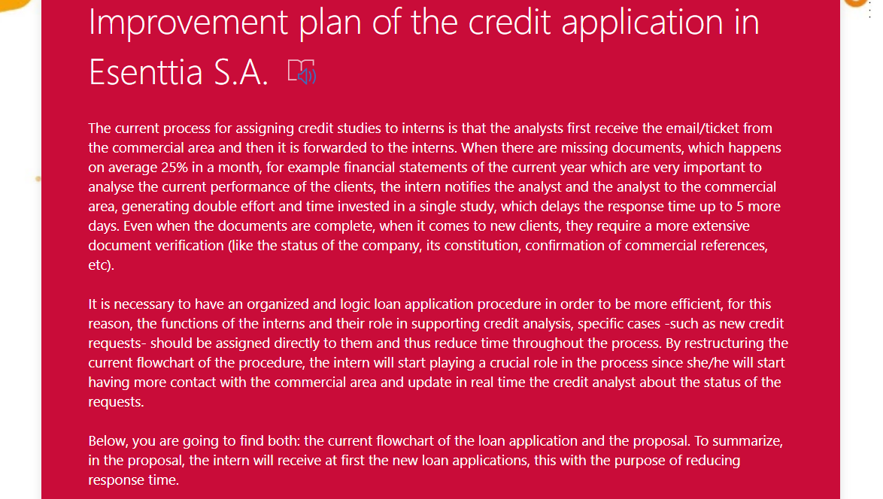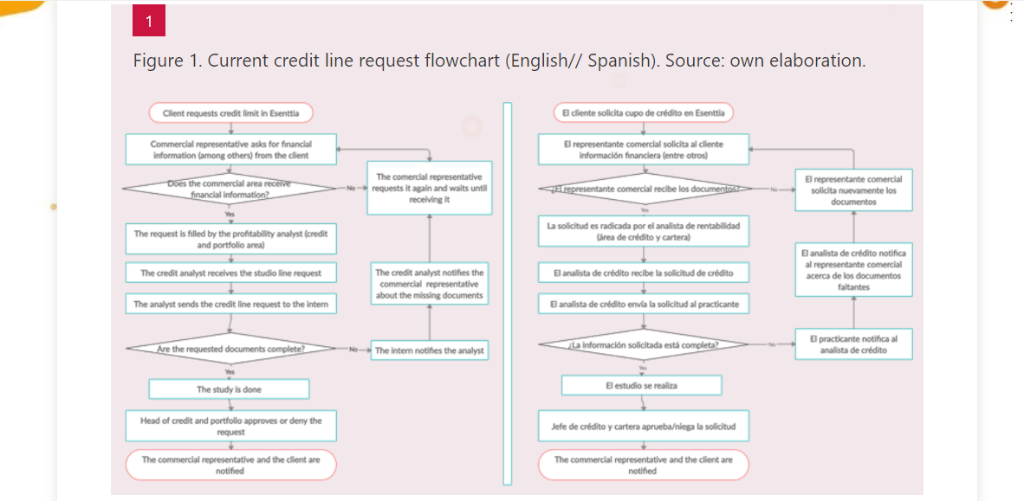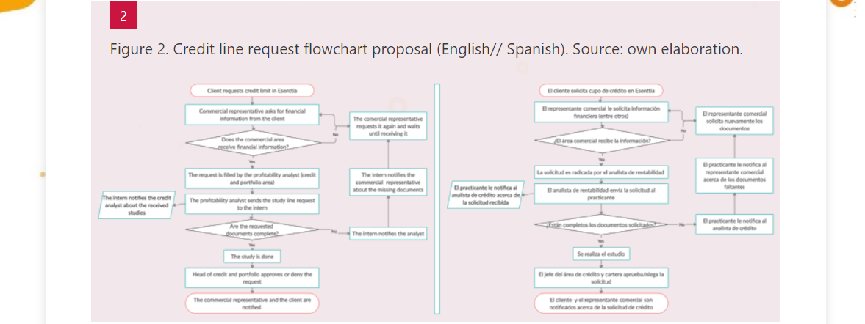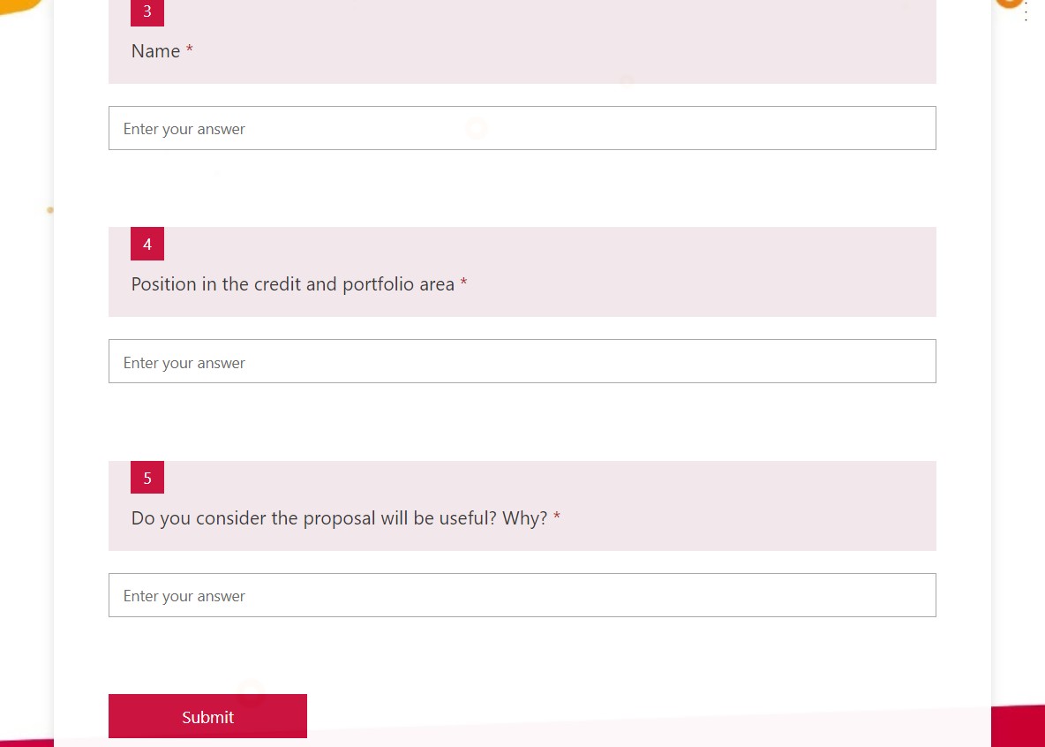

Annex 3. Current credit line request flowchart. Source: own elaboration.
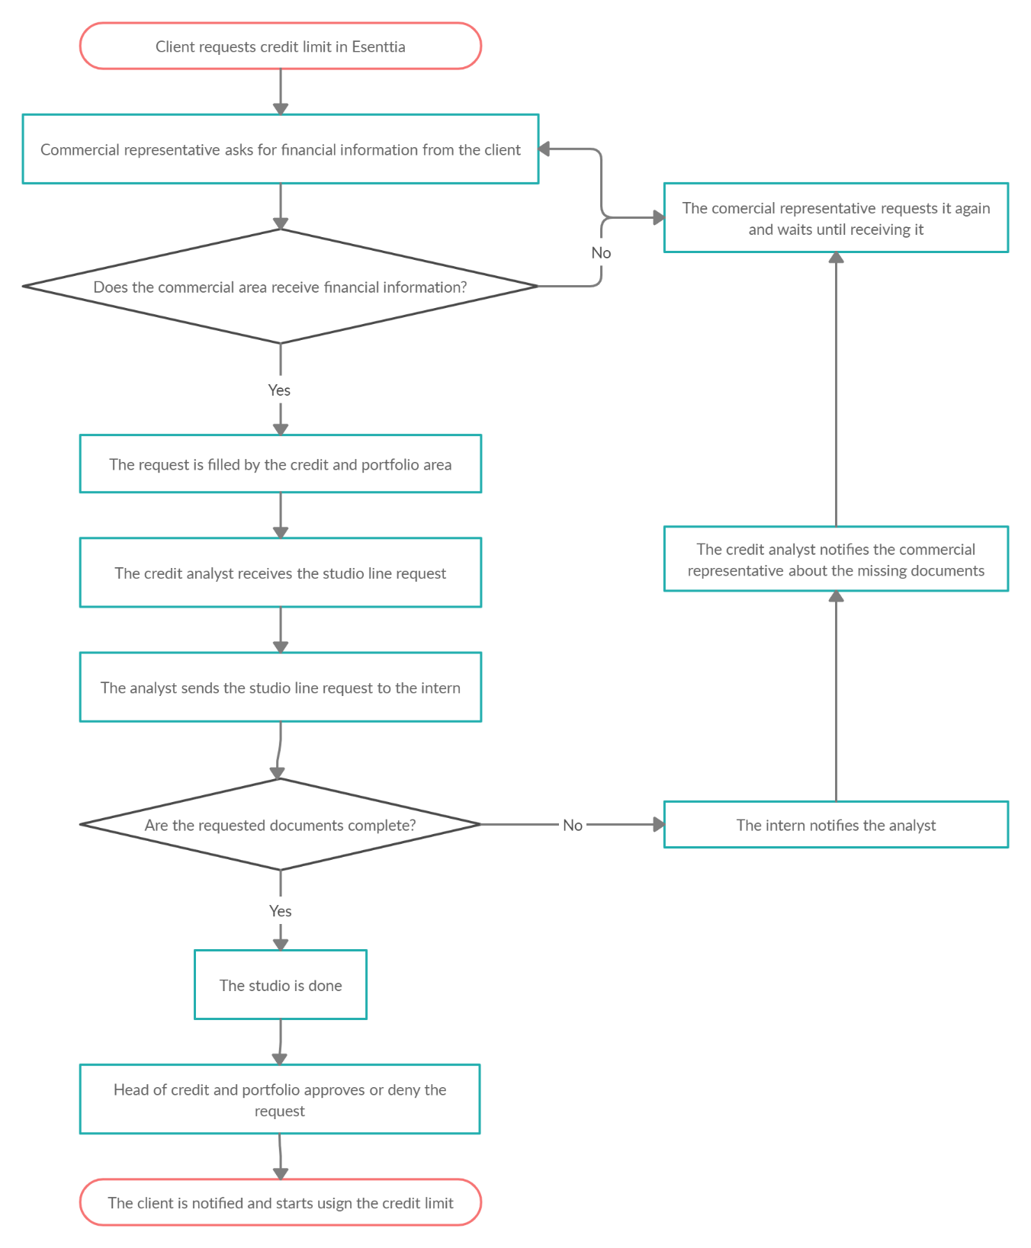

Annex 4. Credit line request flowchart proposal. Source: own elaboration.
