POLITECNICO GRANCOLOMBIANO UNIVERISTY
DAY SHIFT

IMPROVEMENT PROPOSAL FOR THE COMPANY GRUPO EMPRESARIAL SALUD POSITIVA
(DEGREE OPTION)

INTERNATIONAL BUSINESS
BUSINESS ADMINISTRATION

MATEO URIBE RODRÍGUEZ

2020

- INTRODUCTION

The economic, sanitary, and social emergency of the year 2020 generated by the lethal virus called COVID-19 (SARS-CoV-2), that has made a lot of businesses to change or develop new methods so that they can continue to be active in the market, including the health sector (Minsalud, 2020). Both EPS and IPS have been preparing so that they can offer their users, insured and patients all the guarantees including the people who contracted the virus COVID-19, and for the rest of the population.

The Grupo Empresarial Salud Positiva, is an IPS that has been in the market for 9 years which provides different services in the health area among which we can highlight: home therapies of any kind, nursing and wound clinic. In addition to the above, it works with different types of insurers, such as EPS Salud Total, one of the biggest in Colombia, with which they have a contract that offers their entire portfolio.
Nowadays Salud Total offers their insured a 14-day package that’s tracking its COVID-19 positive patients, which contains 14 oximetry test, 14 phone follow-ups, 2 medical home visits and 2 home visits for infirmary, with a unit cost of COP $692,024. Salud Positiva acquired a contract to carry out the development of this package to the users that are assigned by their EPS. In addition to everything that’s already included, it has been shown that the data storage process is precarious to the demands of the patients offered by the EPS.
The following proposal will focus on offering a tool that allows to control, monitor and follow up on the key points of the process, thus reducing the impact of the problems that are presented. It will be done using a computer tool that allows correct handling, monitoring and control of the data. It will be done through Access, a program included in Microsoft Office, one that the company already has a license.
For this reason, the problem to be solved will be proposed first, followed by the development and construction of the office automation tool that will improve the business management of the process, and finally, conclusions and a plan to be followed by the organization, which will be given so that it can improve the process in question.

- JUSTIFICATION

The world is living an extraordinary situation thanks to COVID-19 (SARS-CoV-2), that started in China at the end of the year 2019, specifically in city of Wuhan, it expanded all over the world due to its ease of contagion, thus becoming a pandemic. It has infected, to this date, more than 31.3 million people across the world and have died 965.000 people. (JOHNS HOPKINS UNIVERSITY & MEDICINE, 2020).
Due to the world conjuncture, the EPS Salud Total developed a package that allows monitoring of the process of recovery of the COVID-19 positive patients during their obligatory quarantine of 14 days. The EPS outsourced the process and the IPS Salud Positiva received various patients in the development of this package.
At the time when the Salud Total package was contracted, in the beginning of July 2020, in Colombia existed an average number of 4.000 daily infected (Instituto Nacional de Salud, 2020). As there were so many confirmed daily cases, there was no capacity to correctly monitor the patients in the package, there was also a tool that allows to store that amount of data in an organized and quality manner.
Taking this situation into account and based on the knowledge acquired in the international business and business administration area, an office automation tool will be developed to improve management in the process of acquisition, completion and monitoring of patients in the contracted package.

- OBJECTIVES

- General Objective.
Implement a data storage system that allows follow-up, control and monitoring of COVID-19 patients that belong to the program contracted with the insurer, thus reducing the inefficiencies surrounding the process.

- Specific Objectives.
- Generate weekly reports that allows health regulators know the status of the patients.
- Generate improvements in the internal processes in order to guarantee better monitoring of the COVID-19 patients.
- Reduce time in feeding and elaboration of the data base.
- Reduce administration costs and expenses associated with follow-up, monitoring and control of the package.

- IDENTIFICATION OF THE COMPANY
- Company
The Grupo Empresarial Salud Positiva S.A.S., was founded in 2011 in Bogotá D.C., and was born from the need to provide better care to patients hospitalized at home, it is a private IPS where home care is understood as a resource that allows providing health care at the home of the patient, and due to their physical condition cannot travel to a medical center, where the habitat becomes the point of reference for the patient and becomes the most important part of their personal history. As an IPS a continuous attention, integral and multidisciplinary care is given, grouped into a set of services; Medicine (8 doctors), Respiratory Therapy (14 professionals), Occupational Therapy (5 professionals), Physical Therapy (98 professionals), Speech Therapy (18 professionals), Nursing Assistants (140 professionals), Social Work (1 professional) and Psychology (1 professional); all the professionals mentioned above have a contract for the provision of services. The IPS Salud Positiva is a leader in the provision of home health services, located in the city of Bogotá and its surroundings; it is characterized by generating quality and timely services within the ethical and humanized framework. To date there are an estimated of 4000 users and 7 contracts with EPS and Insurers.

- Economic Activity
Primary economic activity:
8621 (activities of medical practice, without hospitalization)
Secondary activity:
8692 (therapeutic support activities)
Other activities:
8699 (other activities in human health attention)
- Roles of the practitioner
- Billing processes and EPS and insurances collecting accounts.
- Generation of database for different administration processes in the company.
- Support in the operation of the accounting and financial platform Siigo.
- Digital marketing.

- FORMULATION OF THE PROBLEM
- Theorical Referents
According to (OMS, 2020) COVID-19 is the most recently discovered infectious disease caused by the coronavirus. Both this new virus and the disease it causes were unknown before the outbreak in Wuhan, China, in December 2019.
To date there are different forms of contagion according to (ONU, 2020), based on current evidence about the virus, it has been confirmed that it spreads through direct contact with infected people, indirect contact, through infected surfaces or by close contact of secretions from the mouth and nose of infected people, these secretions are released when a person coughs, sneezes, speaks or sings. To avoid contagion, it is recommended to be one meter away from people.
In the field of sampling, according to the WHO cited from (BBC, 2020), in the world there are two types of tests to determine if the person is positive or not for COVID-19, molecular tests and serological tests, the first tests are the most reliable.
Currently COVID-19 is a pandemic that affects many countries around the world. Today there are different theories from different scientists that allow us to make known different points of view about how to treat the disease.
(Corum, Wu, & Zimmer, 2020) classify 21 types of treatments for COVID-19, these are classified by their effectiveness and safety in 5 different groups that are: widely used, promising evidence, contradictory evidence, not promising and fraud or pseudoscience.
- Situation of the company
Taking into account the global conjuncture that began at the end of 2019 in Wuhan, China, and that later extended all around the world causing a sanitary emergency, the IPS Salud Positiva signed a contract in the month of July of 2020 with the EPS Salud Total, with the purpose of bringing attention to patients that presented symptomatology associated with COVID-19, this is aligned with the guidelines given by the National Government.
In the signed contract it was agreed a package that contains: daily follow-up phone calls, taking oximetry’s, taking cardiac frequency during 14 days, also 2 home medical visits and 2 home visits by nursing, all of the above always guaranteeing the biosafety measures of the patient and the professional.
It should be noted that the organization does not have a robust information system to manage its data, all the information is accumulated in databases created without any technical basis or standardization in Microsoft Office Excel. By not having reliable data, it prevents the generation of reports in real time, since it requires an adaptation of the captured data, which translates into wasted productive hours and economic resources of the company.
The lack of administrative organization of the company and the lack of knowledge in the management of the follow-up process for said infected patients, caused that in the first month of following-up with the development of the contract, several inefficiencies were found, such as work overload to the people in charge of process and loss in billing when glosas were generated since the package required proper monitoring and its own evidence.
The financial analysis of the package is explained as follows; the figures described here correspond to an average of 40 people per month; the value of each package is COP $692,024, multiplying it by the average 40 users would be COP $27,680,960, which would be the gross value of all the follow-ups.
The deductions to this value correspond to COP $2,000,000 of the fees of the person in charge of the daily monitoring. Taking the 14 oximetry’s, 14 heart rates and the 2 nursing home visits have a value of COP $13,000 each, including a biosafety kit for the person in charge of obtaining the medical data, they have a monthly value of COP $13,120,000. Unlike doctors, they have a fixed monthly salary of COP $5,000,000, taking into account that per day only 20% of the patients they attend belong to this package, only COP $1,000,000 would represent their fixed cost in it.
In addition to these expenses, an approximate of the 8% of the total value of the package is made in depreciation of equipment and infrastructure, telephone plan, package logistics, use of the establishment and administrative expenses, these expenses were obtained from the company's cost system, for a total of COP $2,214,000.
Considering the values ​​listed above, the package has a net profit of COP $9,346,000, which corresponds to an approximate 33% profit on each package. Given the above context, it is evident the need to improve the management and efficiency of the package in order to obtain higher net profitability; this will be done by streamlining the completion and storage of data, which the administrative professional is in charge of, in the same way, the daily monitoring of patients will be optimized by focusing on quality of care and not focusing on the limitations of the administrative process, so that this way, the fixed administrative expense associated with the package, is reduced, directly increasing the cost effectiveness of the package by 4%.

- IMPROVEMENT PROPOSAL

Currently the data storage process for the COVID-19 package contracted with the insurer oversees a single person throughout the organization. Every day you must record in Excel all the data that the professional asks each patient. These are basic symptom data such as your heart rate, oximetry records, if you have a cough, fever, sore throat, headache, general malaise or loss of sense of smell and touch. Seeing that the management of the company has little knowledge about the process in question, the strategy is decided to implement a technological tool that will allow the standardization of concepts, generating a positive synergy of the process.

From the above, benefits will be obtained from the organizational, service and financial point of view, such as a reduction in the time to fill out each patient's symptoms, facilitates the delivery of reports and their compliance, allows different processes such as it is billing are made so more easily thanks to the centralization of data, and it improves the quality of the service provided by the IPS to their patients, finally, there will be a better visualization of data.

- METHODOLOGY
Taking into account the process that was carried out to obtain data from the patients, it was observed that the way in which it was developed was not optimal for the amount of data that was handled, in addition to that the organization that had the format Excel did not allow a correct visualization of the data for the generation of weekly reports.

As a result of the evidence presented in the previous paragraph and after an interview with the person in charge of filling out the symptoms of COVID-19 patients, where he stated that time was one of the factors that should improve, an easy filling also It would allow the person in charge to carry out additional tasks in the company.

For these reasons, it was determined that the way to solve these inefficiencies was to build a database in Microsoft Access, which would be much easier to fill out, through forms, which in turn would feed the database, without having to be manually entering each data, which would minimize errors and the quality of the data would increase. For the construction of the tool, the contract signed with Total Health was taken into account, and all its parameters to be able to provide an optimal service to the patients presented by the insurer. Next, the step by step of creating the office tool will be shown:
- Construction of the tables with the contractual parameters established by the insurer:

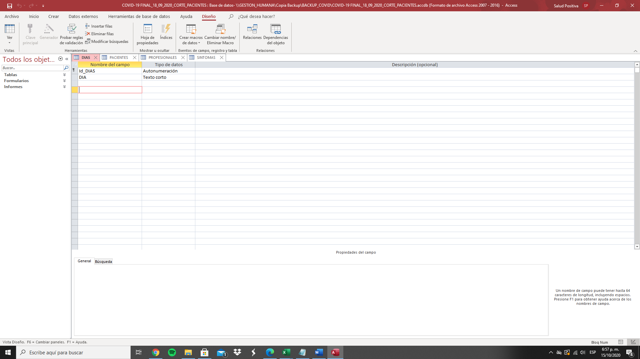
Illustration 1

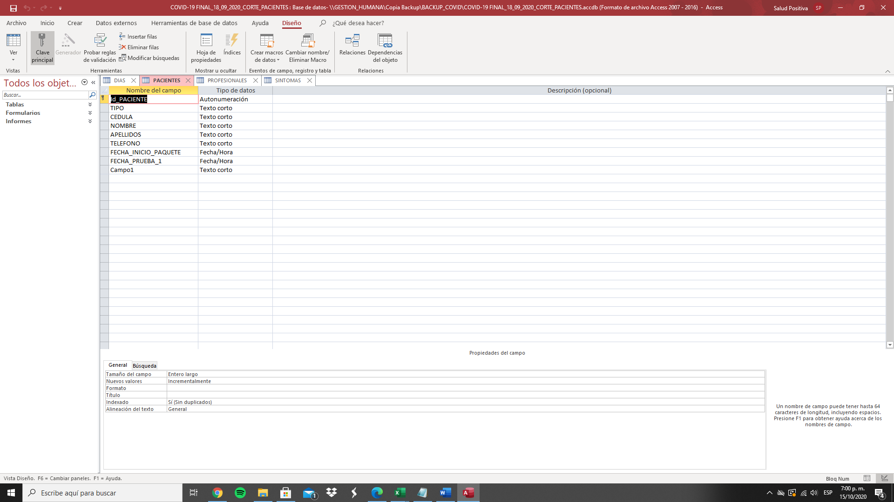
Illustration 2
Illustration 3

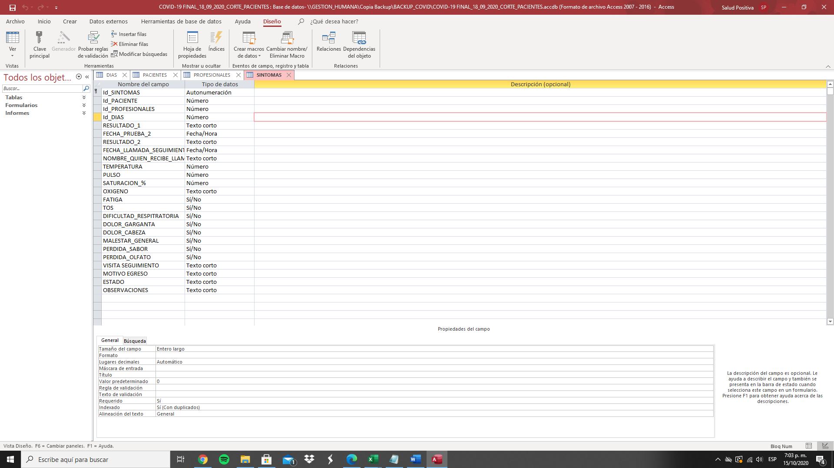
Illustration 4
- An entity-relationship model was used to connect the tables to each other.

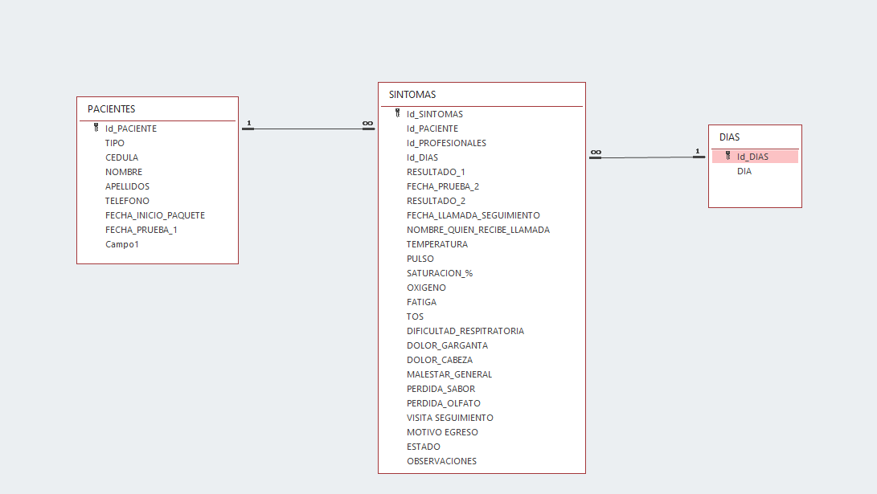
Illustration 5

- Establishment of relationships.

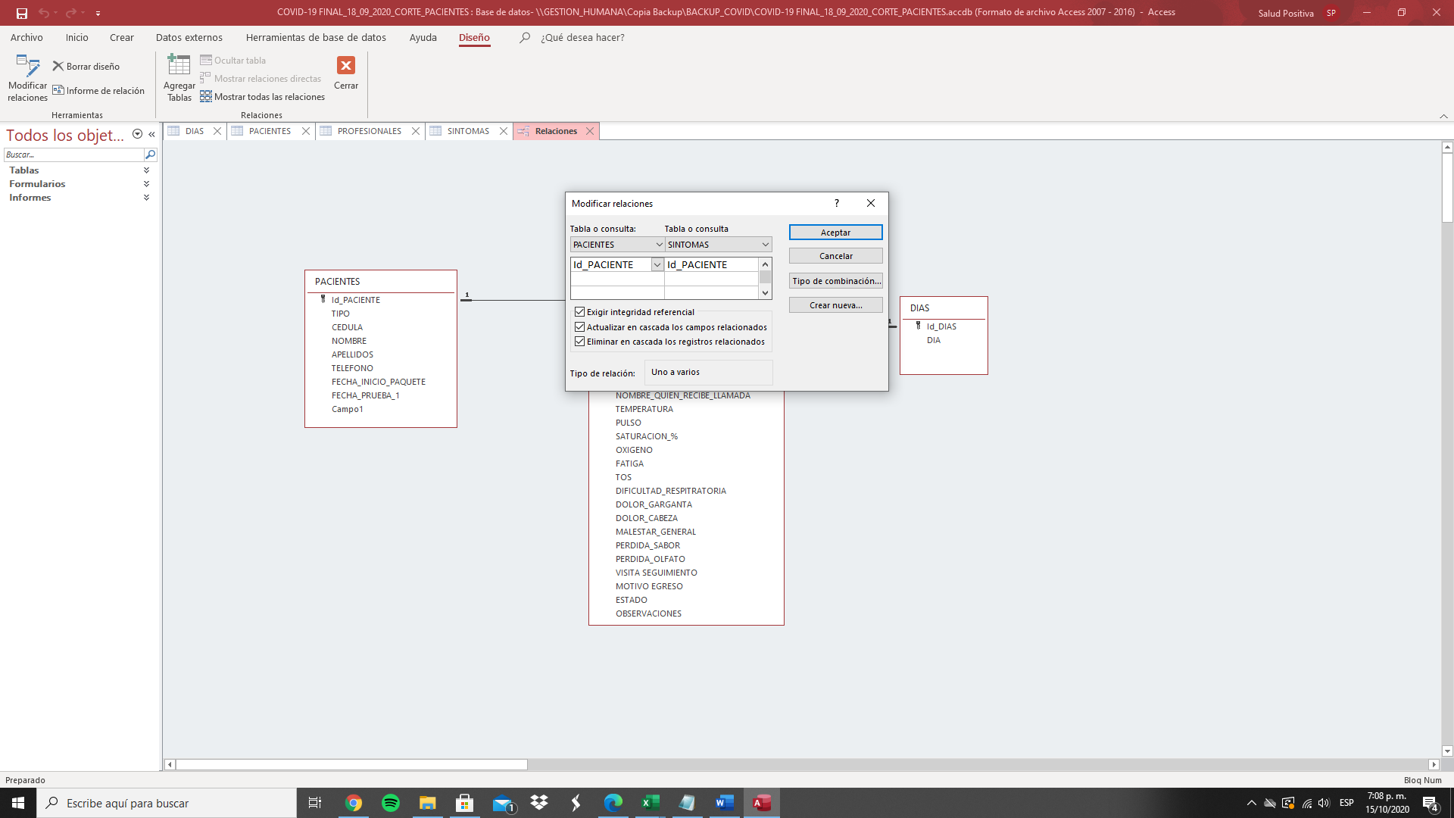
Illustration 6
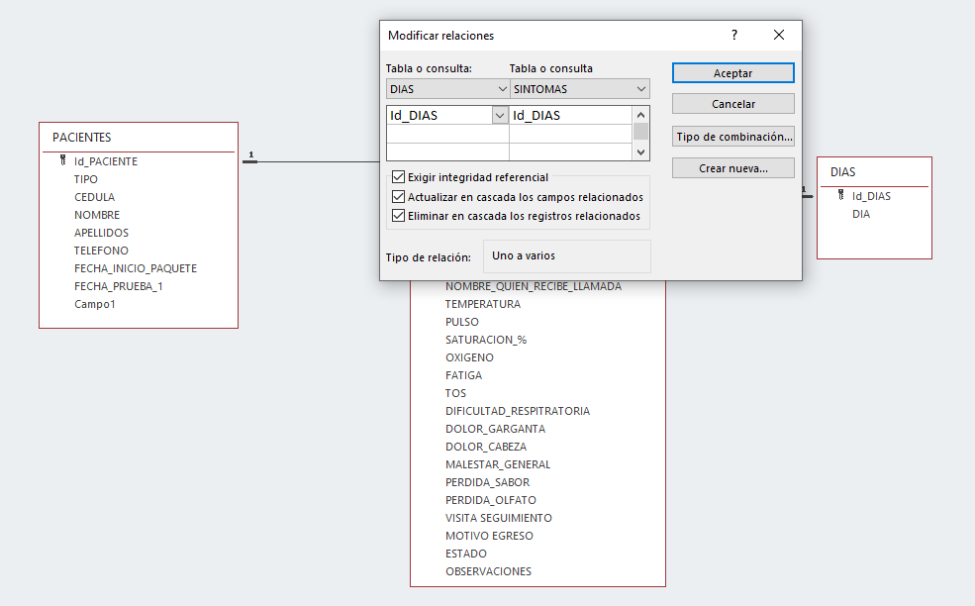
Illustration 7

- Creation of form for the daily registration of patients.
This form simultaneously feeds the tables that were created in the first step.
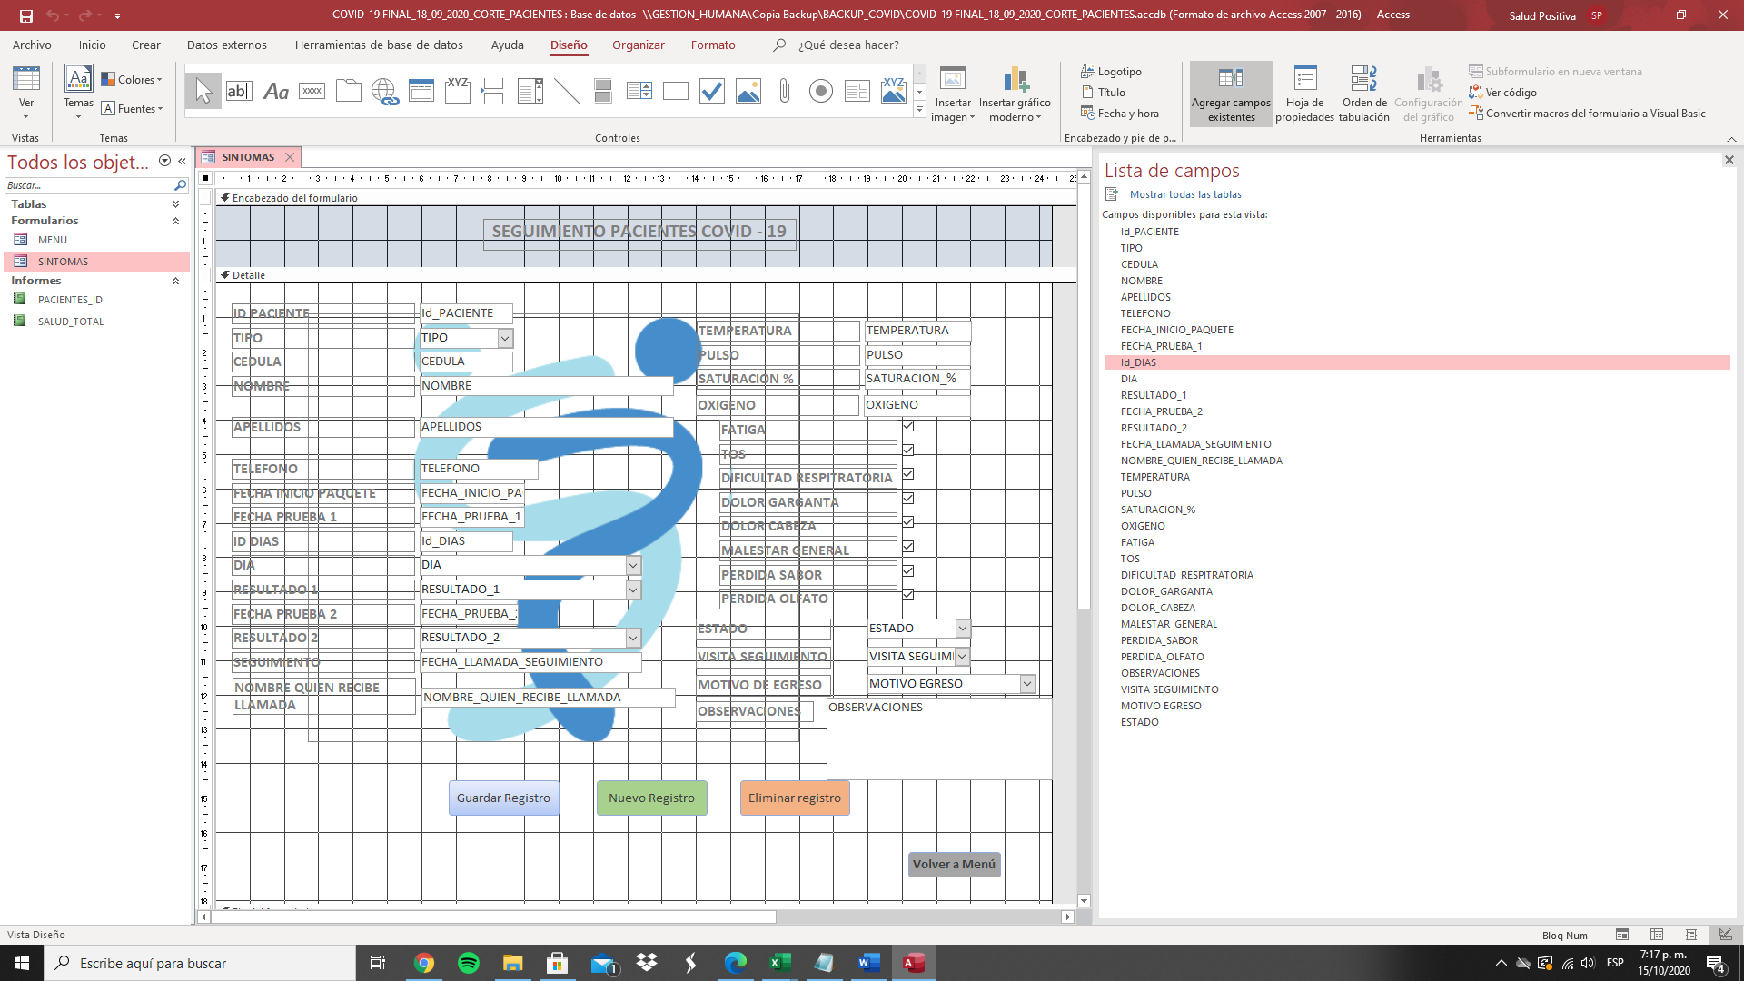
Illustration 8
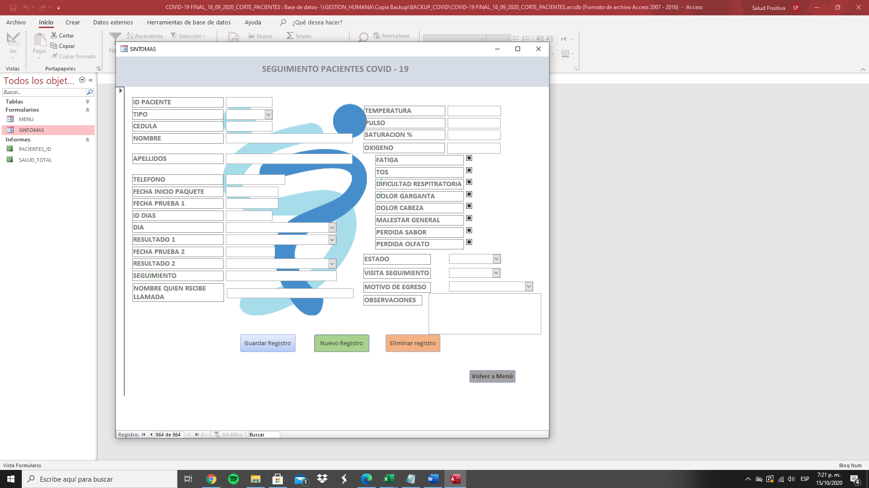
Illustration 9
- Creation of a menu that prevents modification of the database structure.

This menu prevents manipulation of the databases stored in the main form

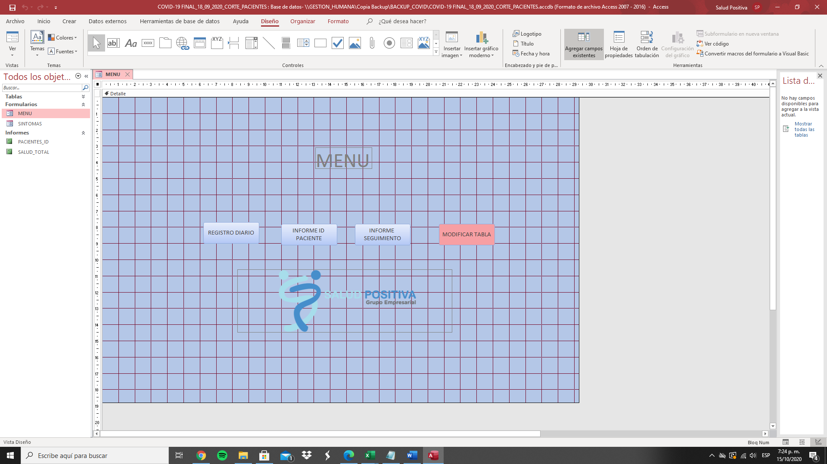
Ilustration 10
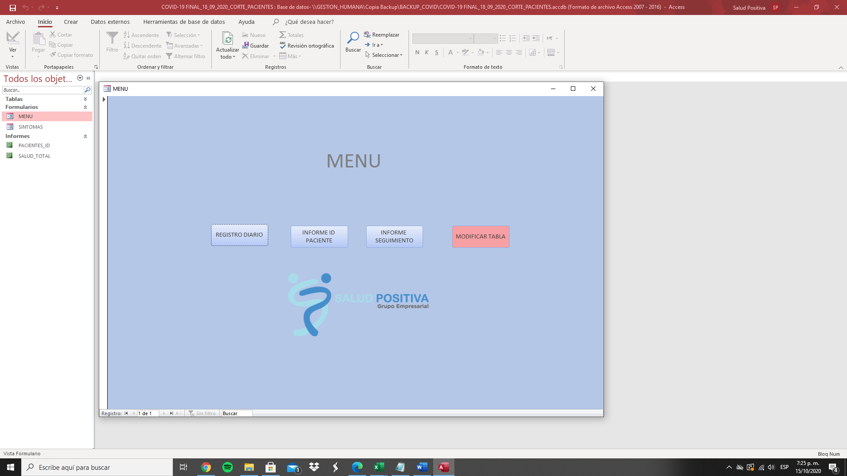
Ilustration 11
- Implementation of daily control report of patients entered in the database. It only contains basic information for your search.

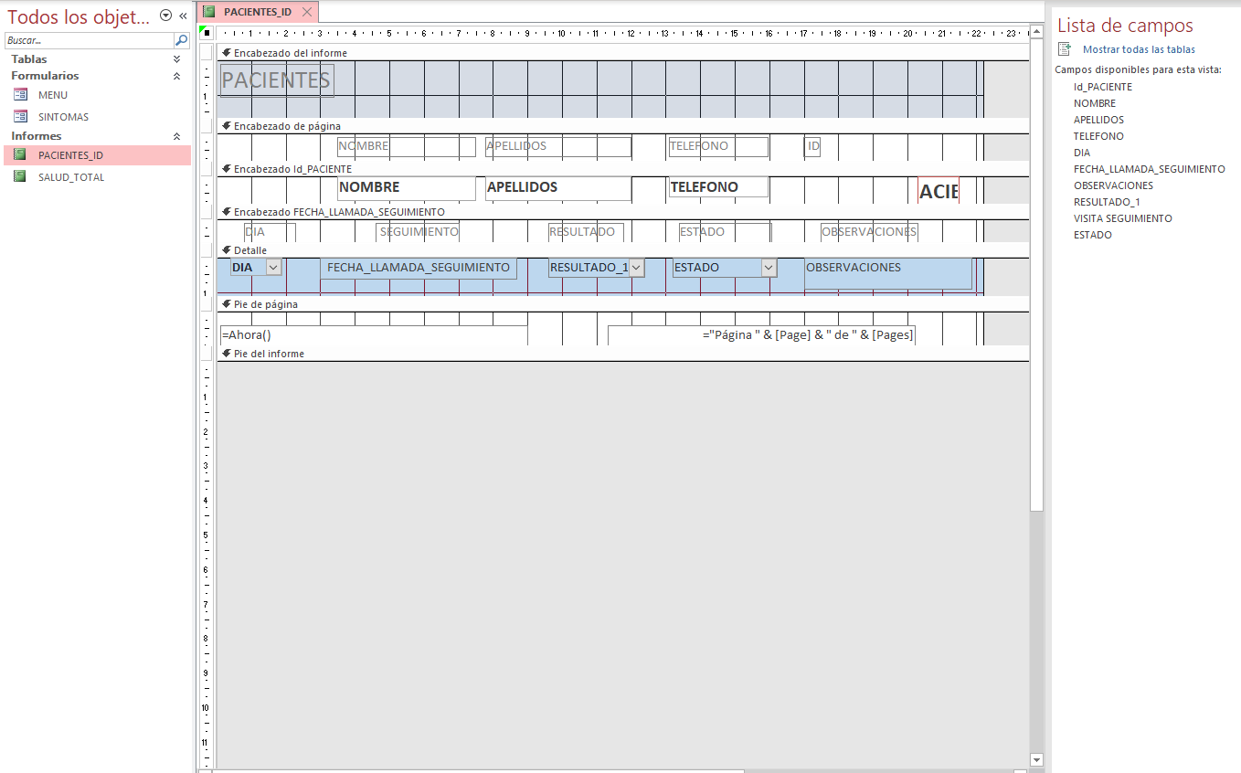
Ilustration 12

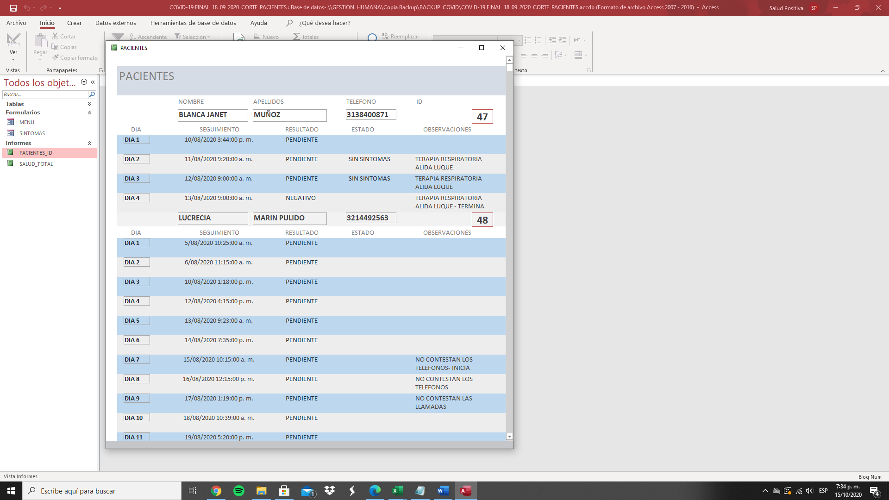
Ilustration 13
- Implementation of report for the contracting insurer.
It contains complete data of the patient, COVID-19 test result, all their daily symptoms and field of pertinent observations.

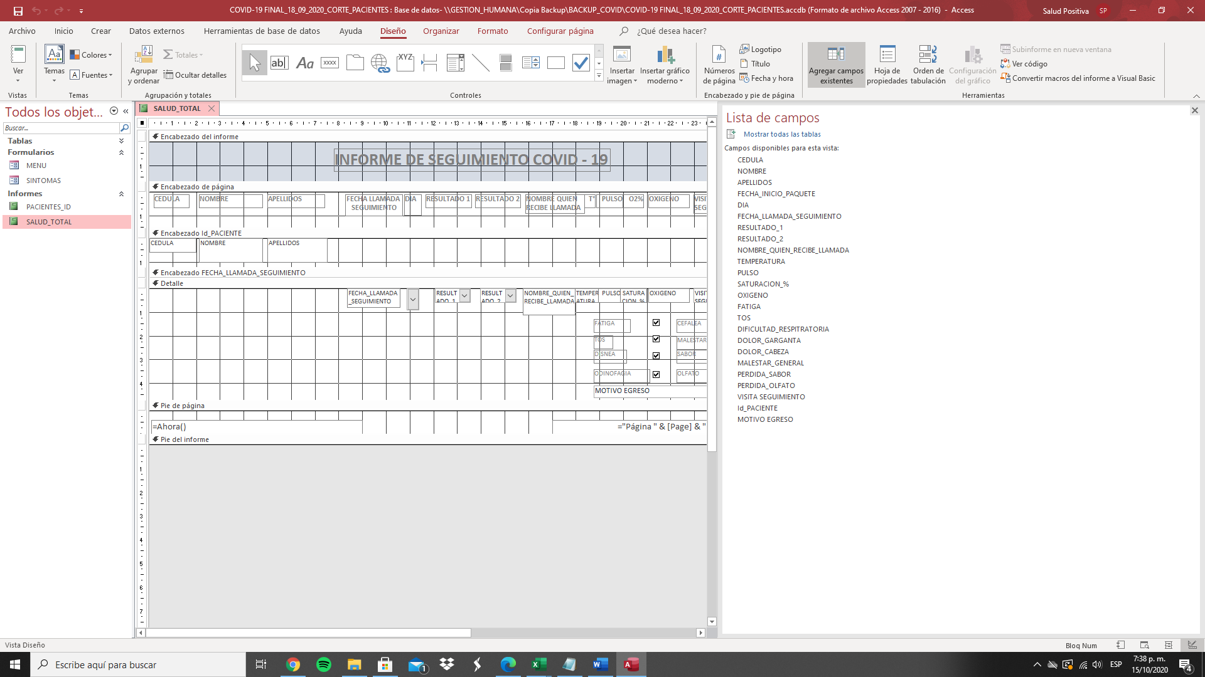
Illustration 14
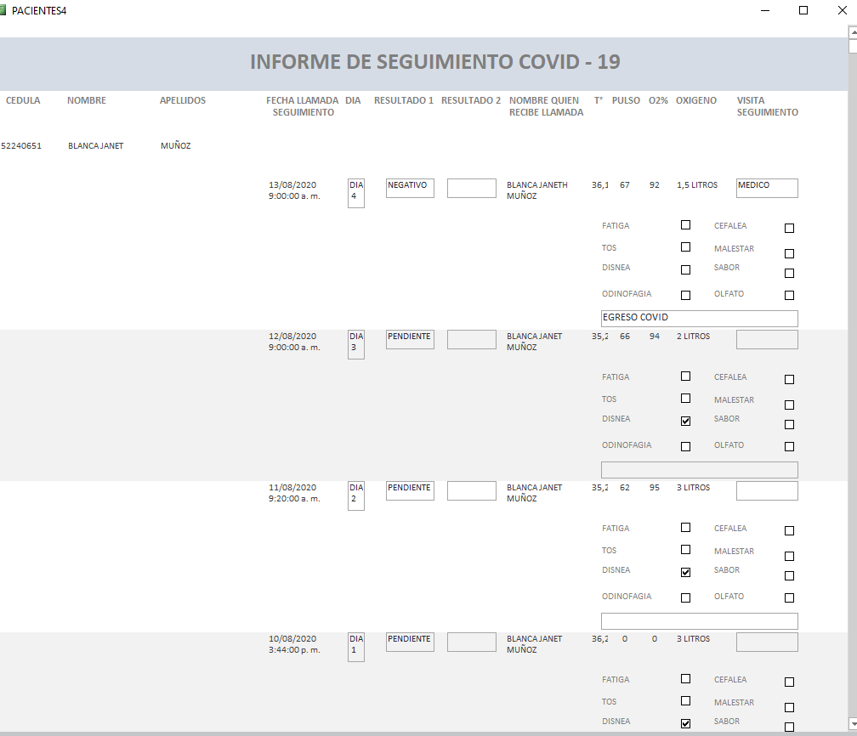
Illustration 15

- DISCUSSION AND RESULTS
The office automation tool, already in progress and on a trial basis, gives the person in charge of handling the facility to perform their tasks in a more agile way. In addition, all the information is centered in a single database, which allows easy reporting, in real time and effectively.
Nowadays, the application is executed by the official who is in charge of the process in question, which has allowed him to cut the process that he had to carry out previously, his benefit is directly proportional in time and labor, since the method has guaranteed a systematization at the time of doing the work.
Likewise, the individual can develop other tasks that he is in charge, this not only helps him to have an optimization in the functions, but also an improvement in the performance of the collaborator is obtained, that is, it contributes to a larger scale to the productivity of the company.
- CONCLUSION

The main objective of this project was to implement an office tool that would allow control of COVID-19 patients; Throughout it, it was possible to develop various tactics that helped carry out the process. This brought with it that the E.P.S. to which the monitoring mechanism was applied could find an optimal and effective solution for receiving reports in the estimated time period (weekly).
On the other hand, it can also be concluded that a benefit acquired by the company was the optimization of resources in terms of reducing time at the time of making the databases. The foregoing guarantees progress with respect to the processes that are executed by the officials in the internal sphere, causing this to positively impact efficiency and effectiveness, thus generating an evolution to the company. In the same way, the reduction of costs and expenses was obtained, this being a pro for the productivity of the I.P.S.

- ANNEXES
- User manual
A User Manual is established that allows anyone in the organization to use the office tool (Video).
- Satisfaction survey}
Through Google Forms, a survey was conducted with the person in charge of the process in question, and I am attaching their responses.
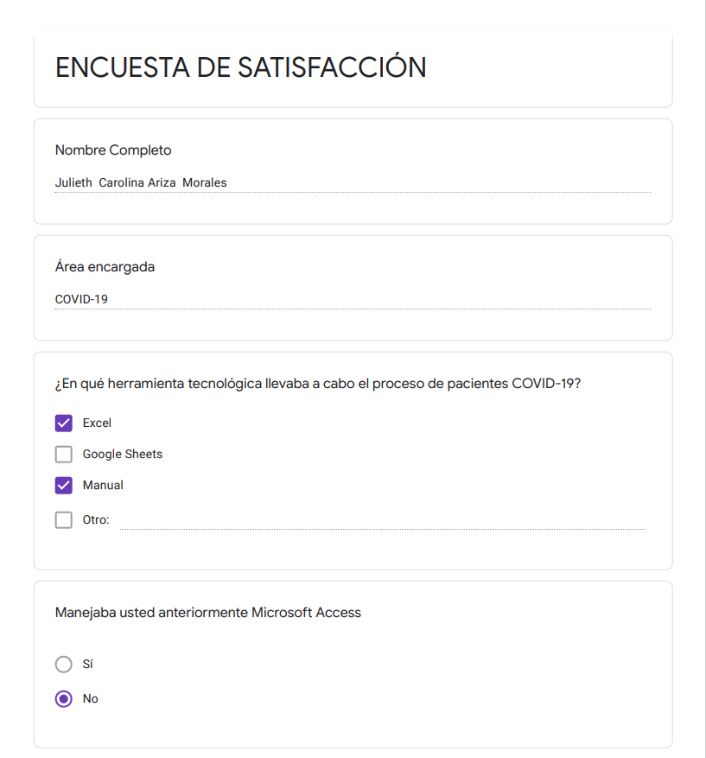
Ilustración 16
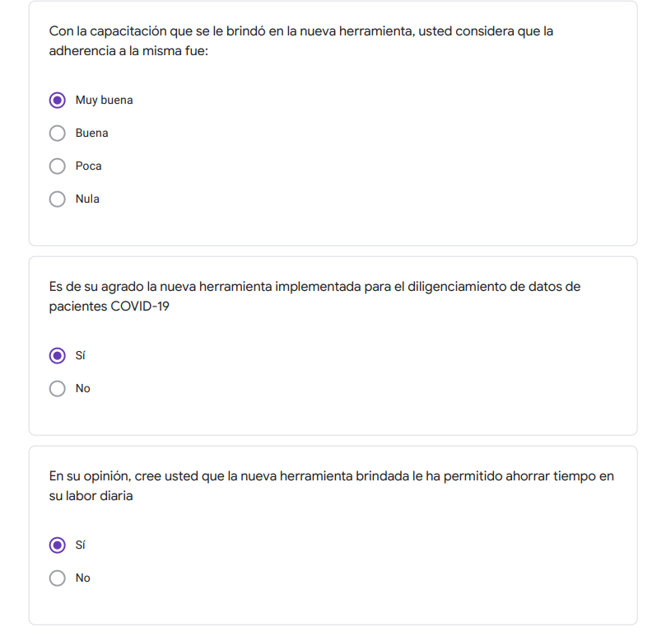
Ilustración 17
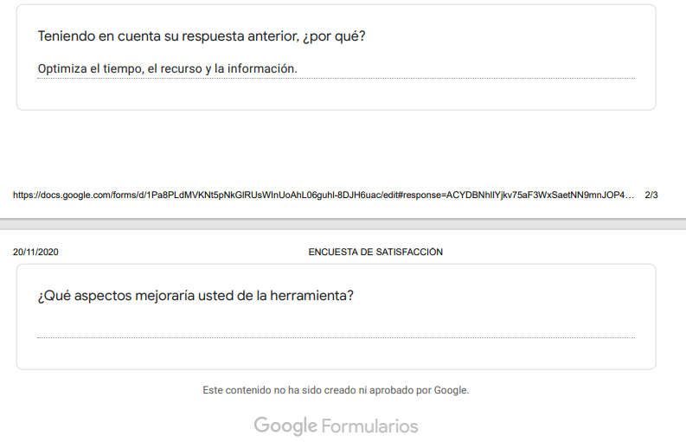
Ilustración 18

Bibliography

BBC. (25 de Abril de 2020). Tests de coronavirus: cómo son las pruebas serológicas y moleculares para detectar el covid-19 y qué ventajas e inconvenientes tienen. Obtenido de https://www.bbc.com/mundo/noticias-52361548
Corum, J., Wu, K., & Zimmer, C. (3 de Septiembre de 2020). The New York Times. Obtenido de Tratamientos y medicamentos para el coronavirus: monitoreo de efectividad: https://www.nytimes.com/es/interactive/2020/science/coronavirus-tratamientos-curas.html
Instituto Nacional de Salud. (Julio de 2020). COVID-19 en Colombia. Obtenido de https://www.ins.gov.co/Noticias/Paginas/coronavirus-casos.aspx
JOHNS HOPKINS UNIVERSITY & MEDICINE. (21 de Septiembre de 2020). Coronavirus resource center. Obtenido de https://coronavirus.jhu.edu/map.html
Ministerio de Salud. (2008). ANEXO TÉCNICO No. 6. MANUAL ÚNICO DE GLOSAS, DEVOLUCIONES Y RESPUESTAS, (pág. 1). Bogotá.
Minsalud. (8 de Junio de 2020). El reto del covid-19 para los sistemas de salud en el mundo. Obtenido de https://www.minsalud.gov.co/Paginas/El-reto-del-covid-19-para-los-sistemas-de-salud-en-el-mundo.aspx
OMS. (2020). ¿Qué es la COVID-19? Obtenido de https://www.who.int/es/emergencies/diseases/novel-coronavirus-2019/advice-for-public/q-a-coronaviruses
ONU. (9 de Julio de 2020). ¿Cómo se transmite el coronavirus que causa COVID-19? Obtenido de https://news.un.org/es/story/2020/07/1477231

Glosa: It is a non-conformity that partially or totally affects the value of the invoice for the provision of health services (Ministerio de Salud, 2008)

